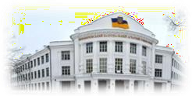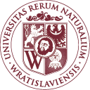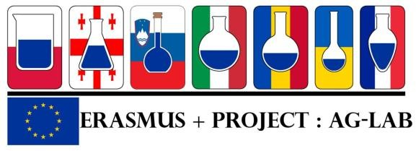

Project “Improving skills in laboratory practice for agrо-food specialists in eastern Europe» (Ag-Lab)
Program Erasmus +, project KA2 n° 586383-EPP-1-2017-1-SI-EPPKA2-CBHE-JP (2017-2978/001-001)

Dates: 03.06.2019 – 28.06.2019
Place: Wroclaw University of Environmental and Life Sciences (WUELS), Poland.
The training had the practical character, classes were hold in the laboratories of Wroclaw University of Environmental and Life Science and in private accredited laboratory Agro-Vet and also in the official veterinarian laboratory in Wroclaw.
Taking into account the complexity of the subject the training was provided in English or in Polish with the translation into English.
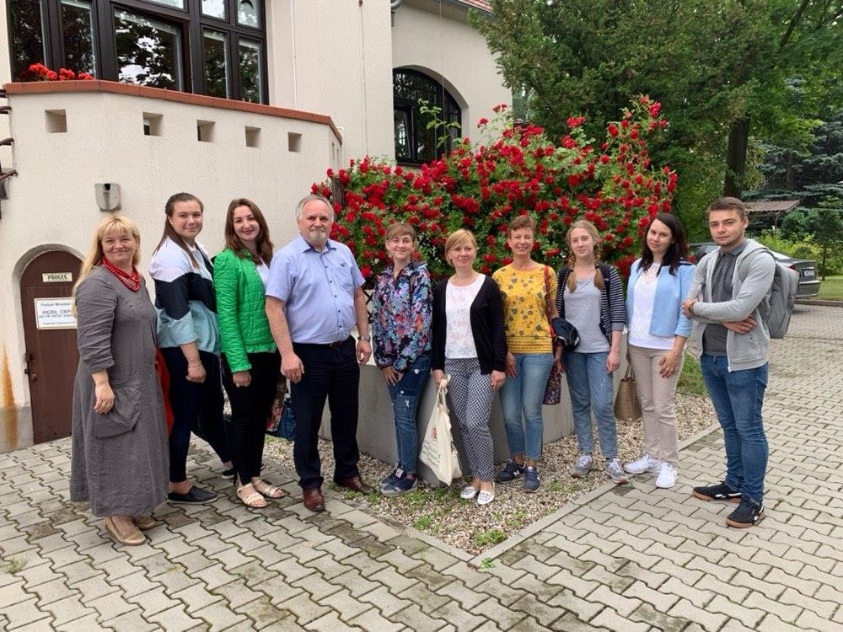

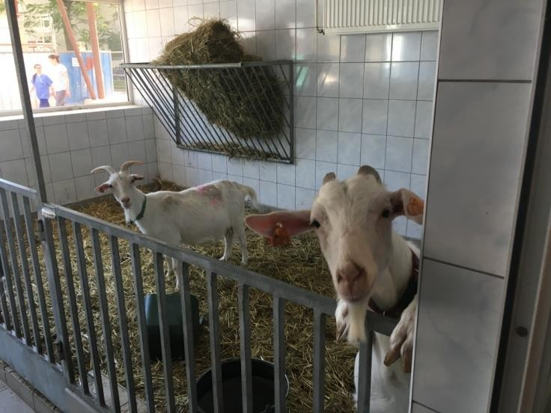
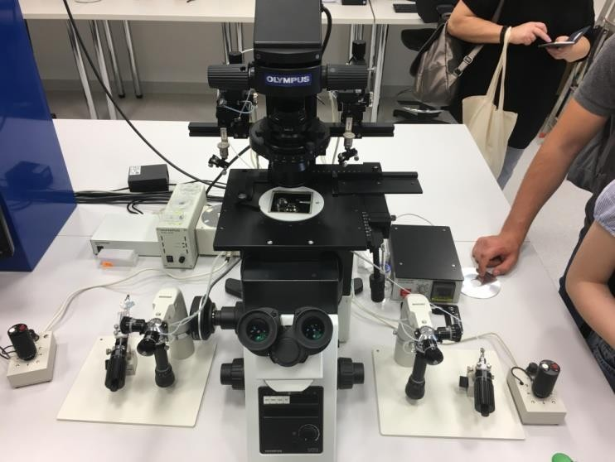
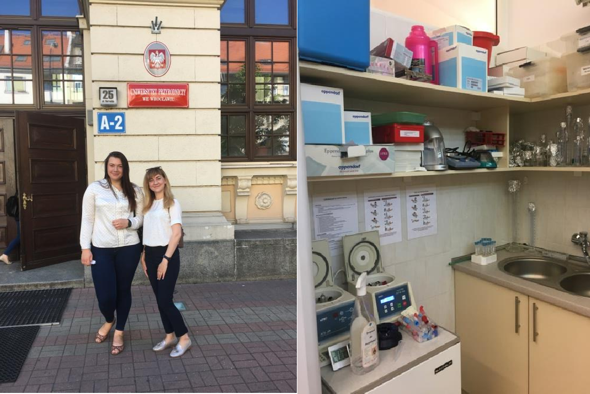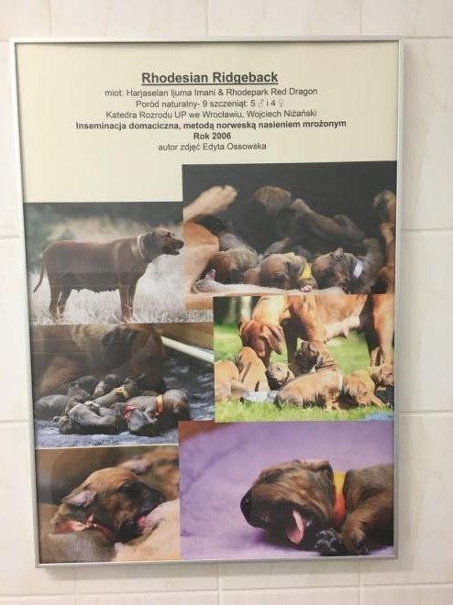

During this training the students worked on detection of staphylococcal enterotoxin genes using PCR in the Department of Food Hygiene. The workshop was provided by dr Ewa Walecka-Zacharska. They made isolation DNA from S.aureus by protocol, check concentration of DNA and then made solution for PCR.

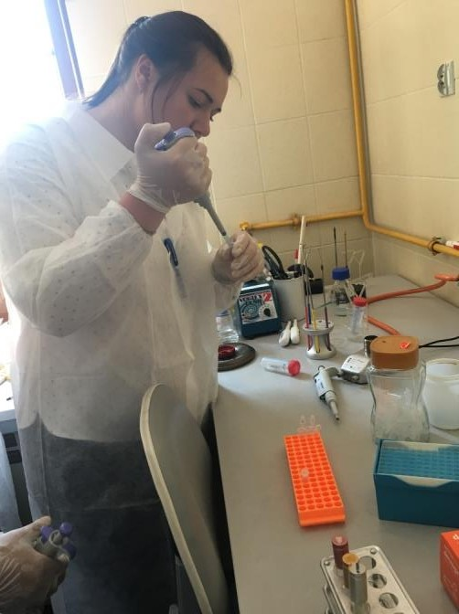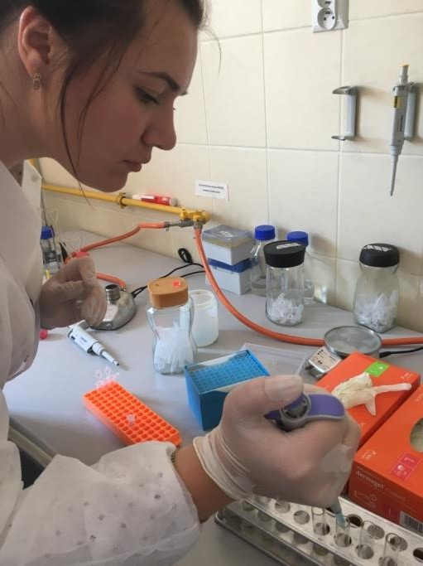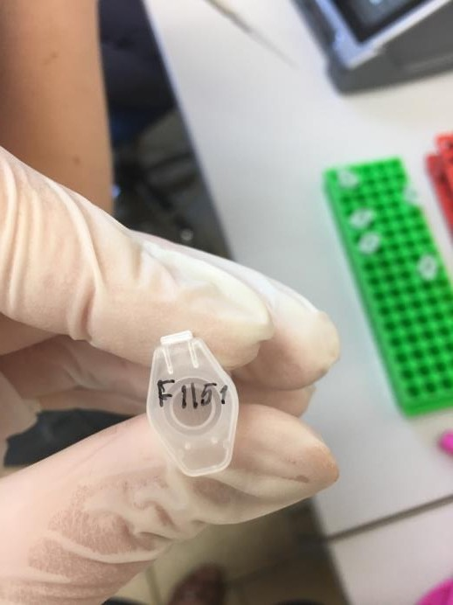
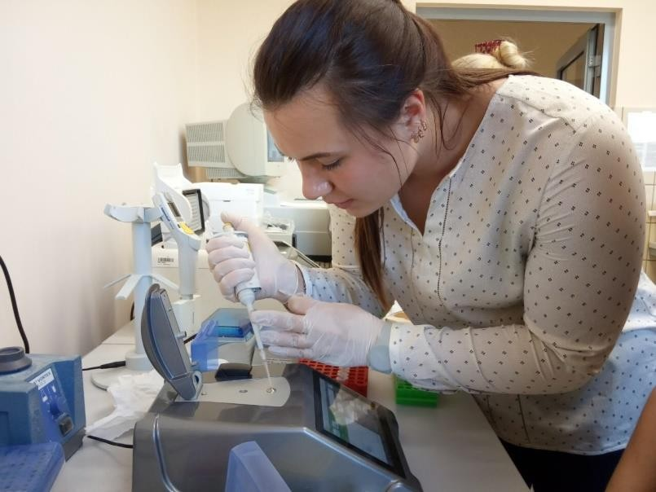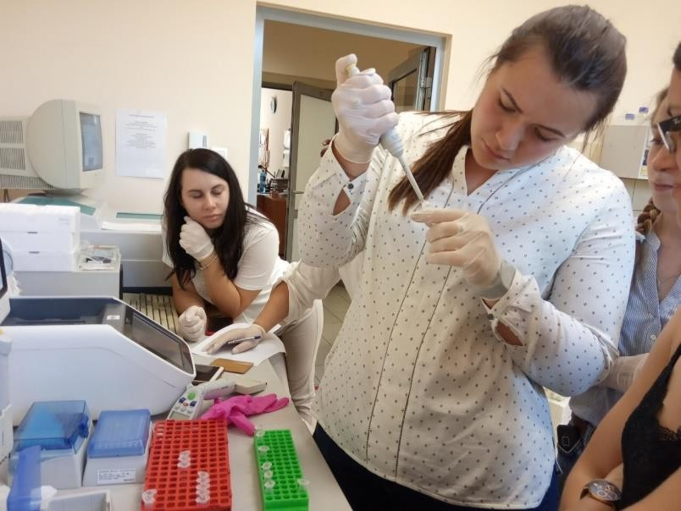

They had training in the laboratories of Faculty of Biotechnology and Food Science. The workshop was provided by dr Anna Zielak- Steciwko. In the first part of our training dr Anna some presentations about education in theirs university and quality requirements of raw milk. Than the students examined few probes of row milk at such indicators like quantity of fat, protein, lactose, dry mater, acidity, density, electrical conductivity and freezing point by different devices to compare the results. They used Bentley 150 Infrared Milk Analyzer, Bentley Somacount 150, Lactoscan Milkanalyzer, Apparatus Draminski.

The students visited Faculty of Biotechnology and Food Science and made Sensory sensitivity tests. Also during these four weeks they worked on the detection of adulteration in food using PCR method, they made liquid extraction of butorphanol samples from the biological samples for the high-performance liquid chromatography (HPLC) coupled to an electrochemical detector.

They visited several laboratories such as the Epi-vet laboratory at The Clinic oh Infectious Diseases, the private accredited laboratory Agro-Vet, that makes examinations of poultry and poultry meat, for accreditation, the official veterinarian laboratory in Wroclaw. The Department of Veterinary Hygiene carries out its tasks through four thematic workshops: Laboratory of Food Products and Feed Chemistry, Laboratory of Food and Feed Microbiology, Laboratory of Diagnostics of Infectious Diseases of Animals, Serology Laboratory. The laboratory performs official examinations commissioned by the Chief Veterinary Surgeon and Poviat Veterinary Surgeons as well as service examinations commissioned by animal owners, food producers and animal feeds.
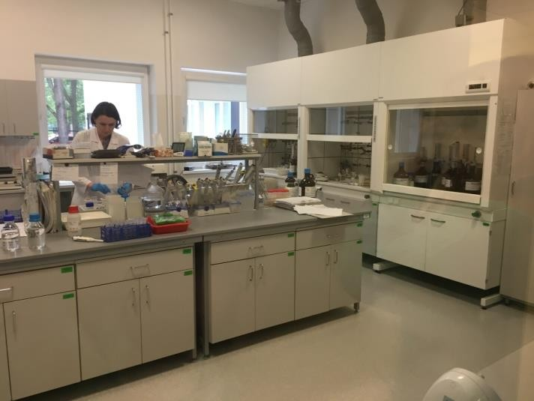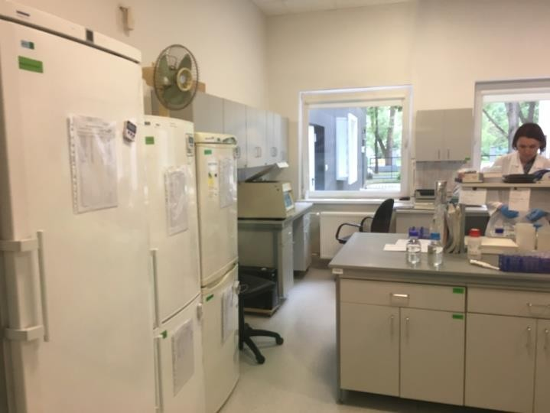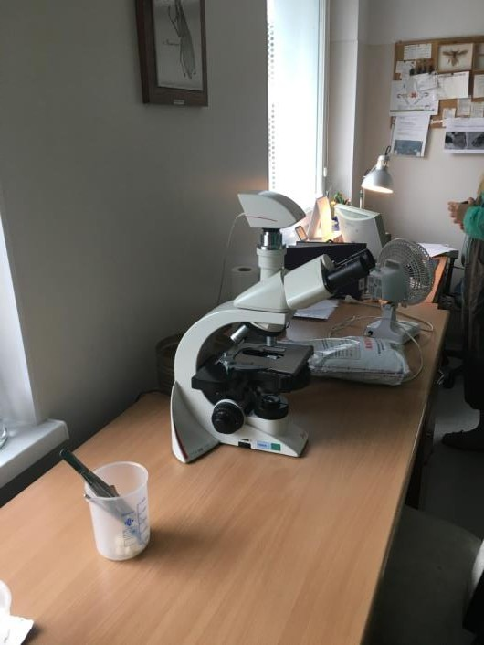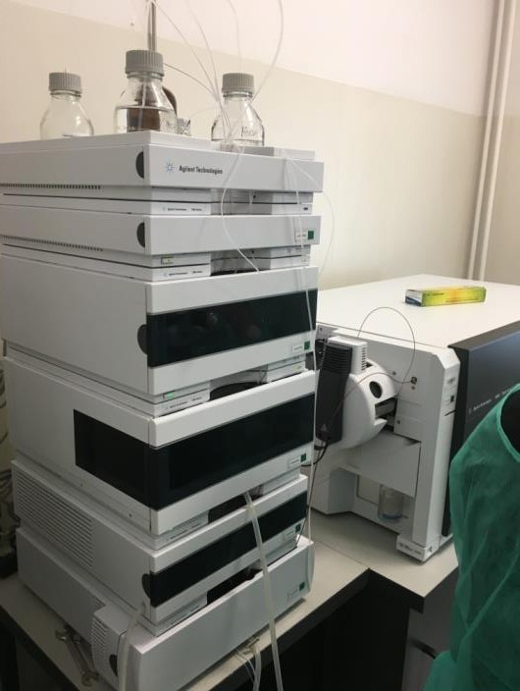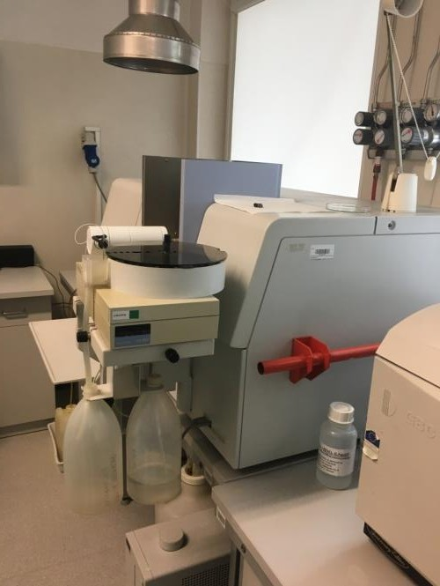

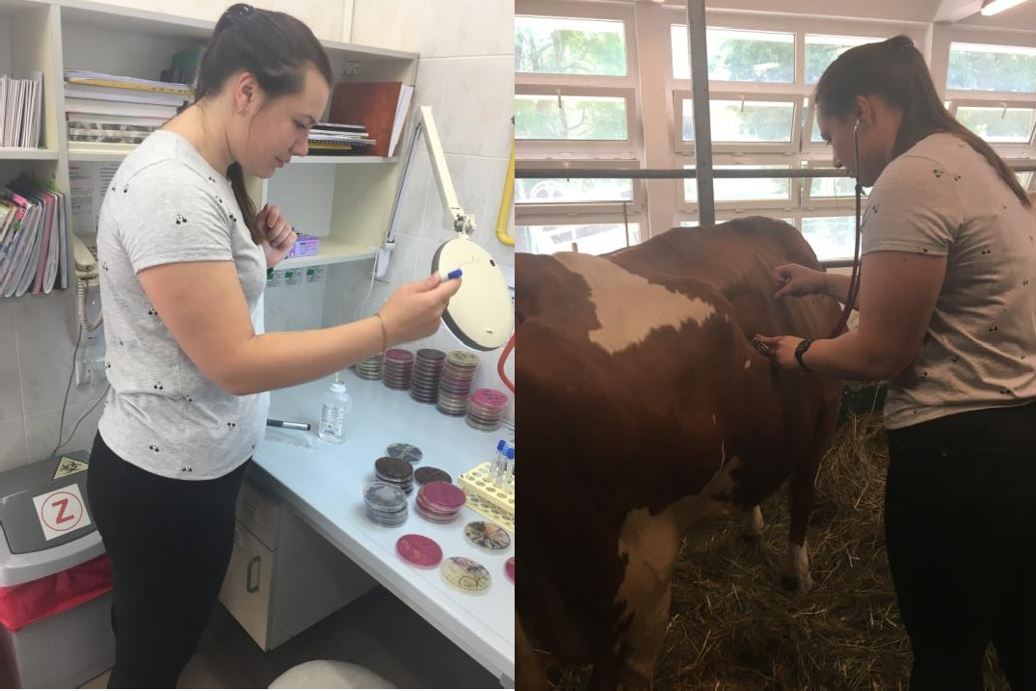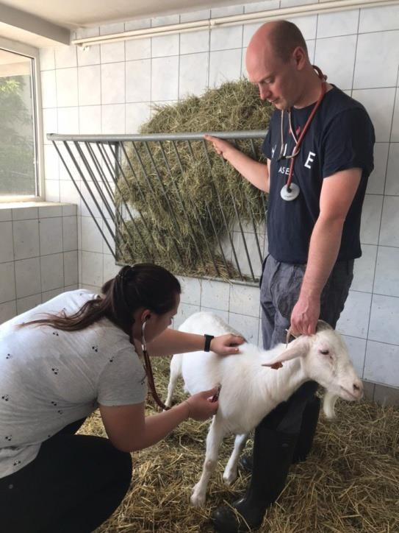

They worked in the clinic of Reproduction and Obstetrics and Farm Animals and conducted an ultrasound of the prostate and testicles of the dog for the presence of pathologies to find out how good it is for breeding. Also conducted an ultrasound examination of the genital organs and other organs of the abdominal cavity and the heart of the female for the presence of pathologies.
