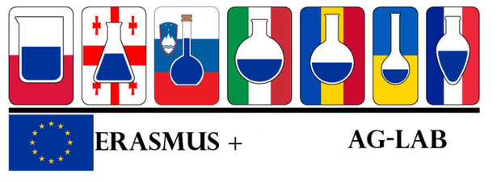
The 5th Student training session took place from 12 November to 6 December 2019 at VetAgro Sup Lyon. Two students, Kristina Senych and Viktoria Gapon from Sumy National Agrarian University in Ukraine undertook an internship under the leadership of the head of the metrological dept Mr. Robert Gerard. The training session was dedicated to the study and practice of metrological procedures in the laboratory. The students are making a short film about their internship which will soon be available.
