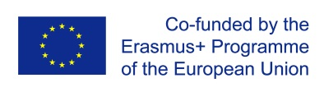
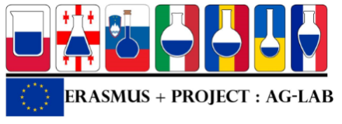

Project “Improvingskillsinlaboratorypracticeforagrо-foodspecialistsineasternEurope» (Ag-Lab)
ProgramErasmus +, projectKA2 n° 586recommendations-1-SI-EPPKA2-CBHE-JP (2017-2978/001-001)
Minute of the seminar for srakeholders
Kyiv, 25 February 2020

Participants: representatives of the National Erasmus+ office, Ministry of education and science of Ukraine, institutions – members of the consortium, Ukrainian HEIs (Zhytomyr agro-ecological university, Poltava state agrarian academy, Lugansk national agrarian university, Kharkiv national agrarian university, Central Ukrainian national technical university, Tavria state agro-technical university).
Welcome speeches:
- Tetiana Ishchenko, director of the Science and methodological center of higher and pre-higher vocational training, mentioned the purpose of the project and concrete steps that are carried out for its realization: creation of the specialized master programmes on the laboratory practice for specialists of the agro-food sector, creation of the specialized courses of the post-graduate training for staff of acting agro0food laboratories, up-grading of the training carried out by laboratories, development of new collaborative practice between universities and laboratories based on win-win principle. She notices the importance of the sustainability of the project results after its end.
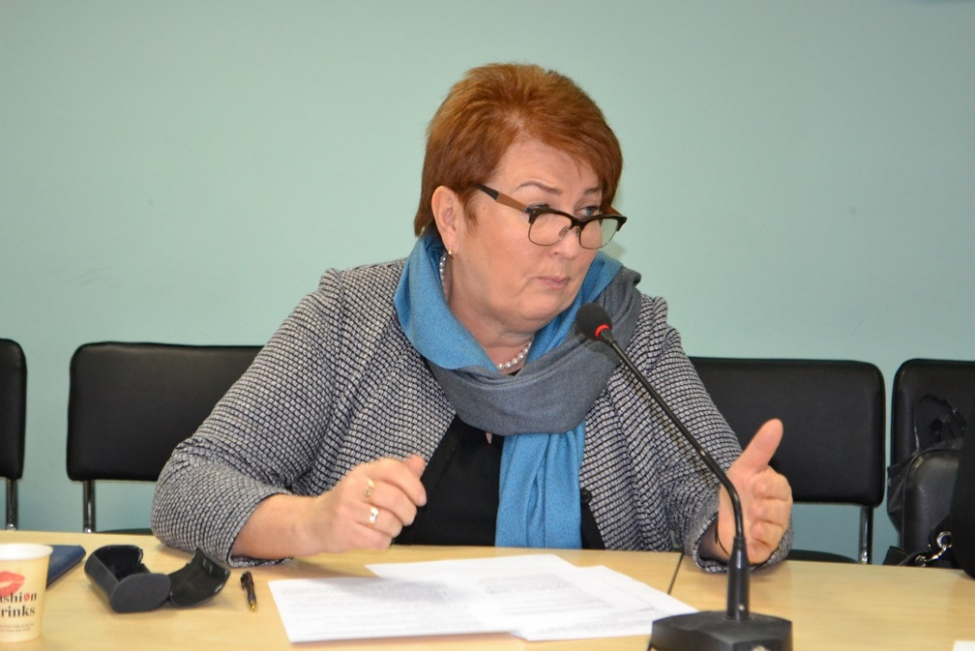
- Svitlana Didusenko, head of the unit of higher education modernization, of the main office of higher education of the Directorate of higher and lifelong education of the Ministry of education and science of Ukraine, noticed the importance of the Erasmus+ programme for the reforms in the higher education in Ukraine and indicated the results expected from this project: cooperation of education with business, adaptation of future specialists training to the industry needs, participation of future employers in the professional training of students, close cooperation of universities and laboratories, organization of common trainings, writing of common articles, editing of training materials, creation the possibilities for international cooperation for young specialists, study of EU standards and their implementation for young specialists.
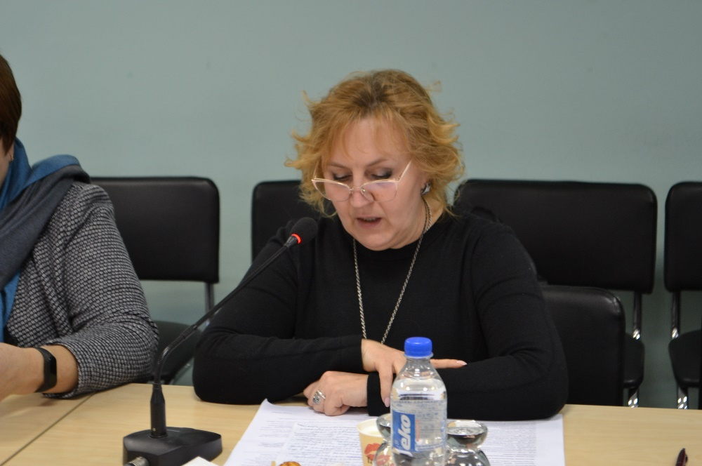
- Zhanna Talanova, expert for analytical issues of the National Erasmus+ office in Ukraine, greeted the participants of the meeting and pointed out the requirement of the European Commission to Erasmus+ project and other projects in the field of education and sciences. These requirements are: synergy, quality of project and its results, respect of the education standards, that also are changed, updated, improved toward the adaptation of EU requirements. She invited the project participants to familiarize with the national legislation in higher education, to study carrefully all information provided on the sites of the Erasmus+ office and the Ministry of education and science of Ukraine.
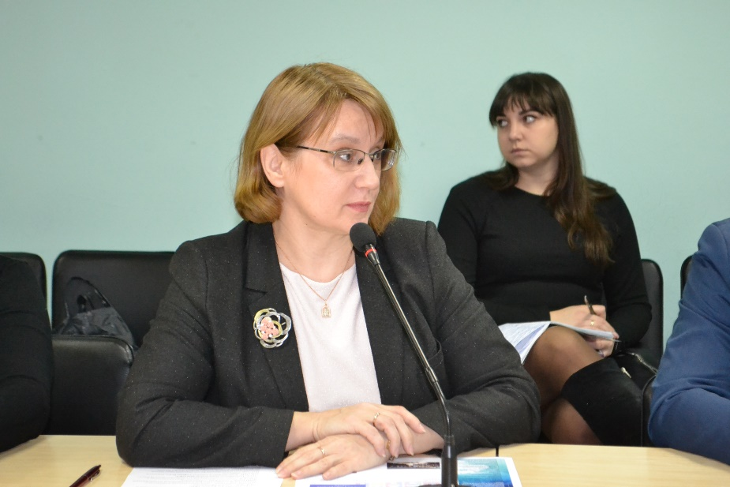
Presentations of the seminar participants:
Olga Getya, head of the cabinet of international cooperation and national co-coordinator of the project presented the results of the project activities during two years: 7 study visits of universities teachers and laboratories staff to the european HEIs – members of the consortium; students training at four European HEIs during one month, three expert missions and three training sessions for the project participants organized in the partner countries, development and implementation of the modules in the framework of the educational programme “Laboratory practice” at the following master courses: agronomy, veterinary medicine, animal husbandry and food technologies. Since the project beginning two promotions of the students were recruited, the first promotion received already their diploma. The universities have purchased the equipment and equipped the laboratories for educational and research purposes. The programme of the post-diploma training for laboratory staff was elaborated. An active cooperation between universities and laboratories was launched in form common training sessions, practical trainings for students, common editing of the manual ‘Laboratory practice”.

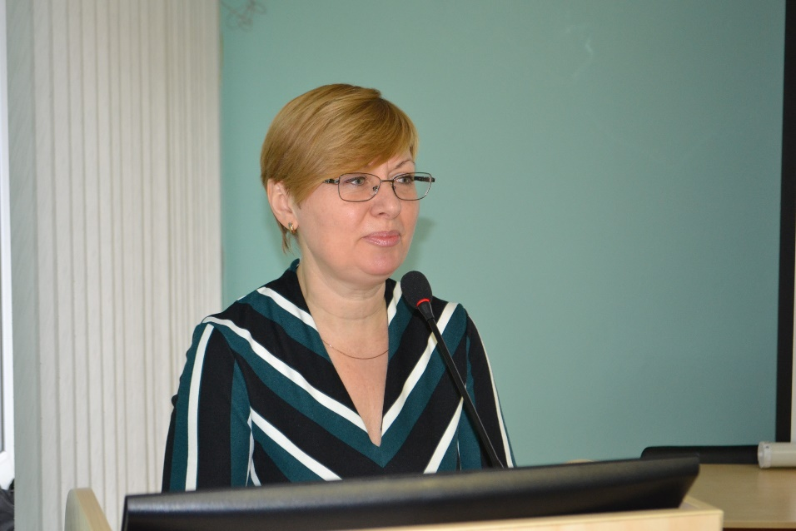

Ludmila Stepura, methodologist of the cabinet of international cooperation and national co-coordinator of the project, presented the project products that can be used by stakeholders and further activities until the end of the project. These products are: manual “Laboratory practice”, that is a result of the common work of all project participants and will be edited in the electronic version, is destined to master students of all specialties covered by the project, can be used by laboratory staff for updating their knowledge and for the training of newly coming specialists. It gives the general knowledge, explains the main laboratory manipulations: different analytical methods, sampling, security measures in laboratory, international standards. Actually the English version is being finalized, that it will be translated into Ukrainian, Georgian and Romanian. She presented also the web-portal of the project and showed how stakeholders can find the useful information there. The further activities are: finalizing of the work on the manual, second promotion of the students according to the specialization “Laboratory practice”, students mobilities between Ukraine, Moldova and Georgia, one more cycle of study tours to EU partners, common classes organized by the universities teachers and the laboratories staff, closing conference in Kyiv.
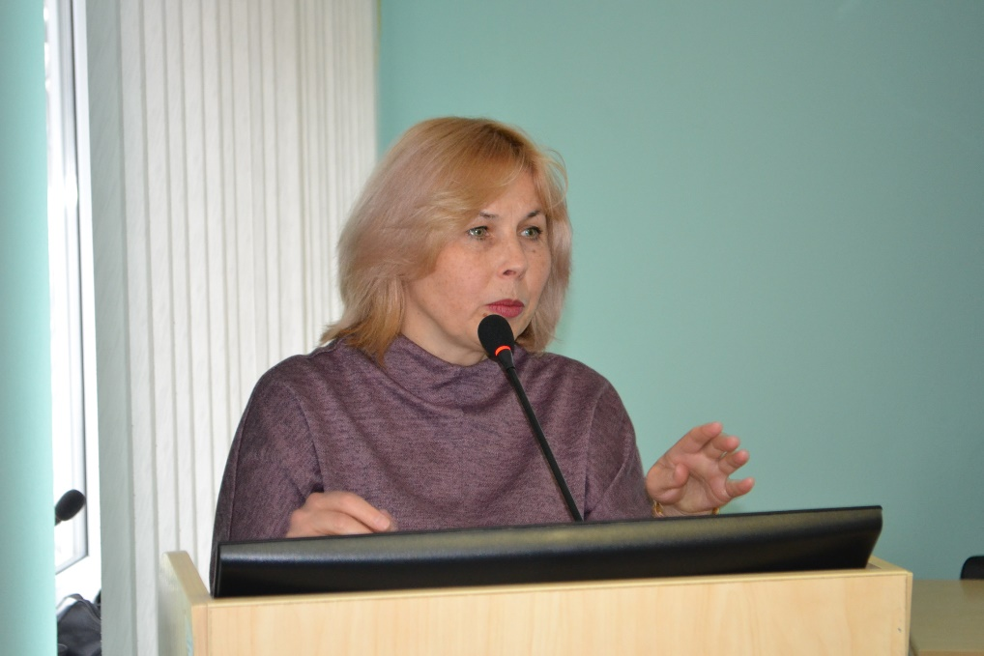
Igor Vereshchagin, associate professor of the department of seeds breeding of Sumy national agrarian university, responsible for completing the Moodle platform with the training courses together with the European association ISLE, leader of this working package, presented possibilities for using the Moodle platform on the example of his own elaborated course “Cellular and molecular biology”. However some weaknesses of the platform were discovered, namely is not easily accessible for any user: in order to get the access, it is necessary to write to the administrator from the Association ISLE, than he will authorize the user and will provide him the login and the password. It was decided to correct urgently the platform, to make it accessible for a large public and the authorized access will be reserved only for authors of the courses as they should edit the content on the platform.
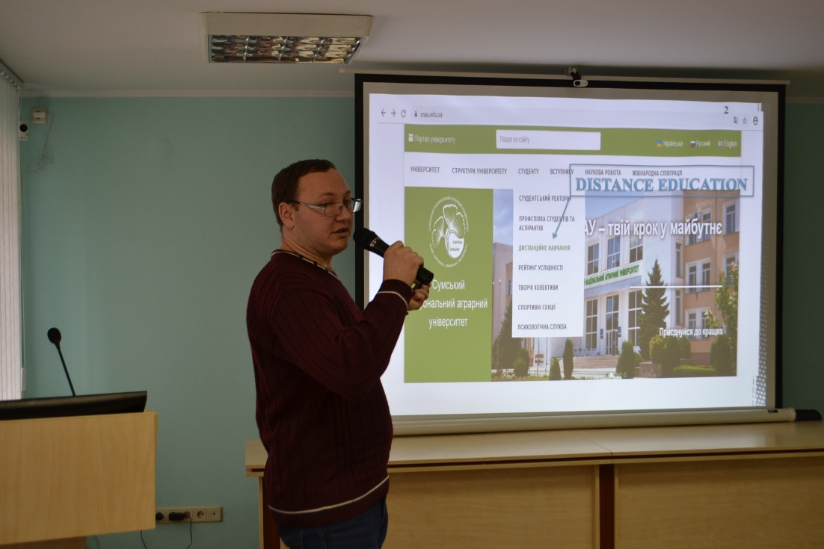
Sergiy Gryshchenko, deputy dean of the faculty of animal hubendry and fishery of NUBiP presented the results of the faculty participation in the project, namely: development and implementation of three modules: Organization of activity and carrying out analyses at laboratory, Modern equipment and methods of laboratory diagnostic, Application of ICAR recommendations in the animal husbandry for the educational programme “Laboratory practice in animal husbandry”; purchase of the equipment for the laboratory at the department of genetics, animal breeding and biotechnology; students and teachers mobility; first promotion of master students trained according to the new educational programme.

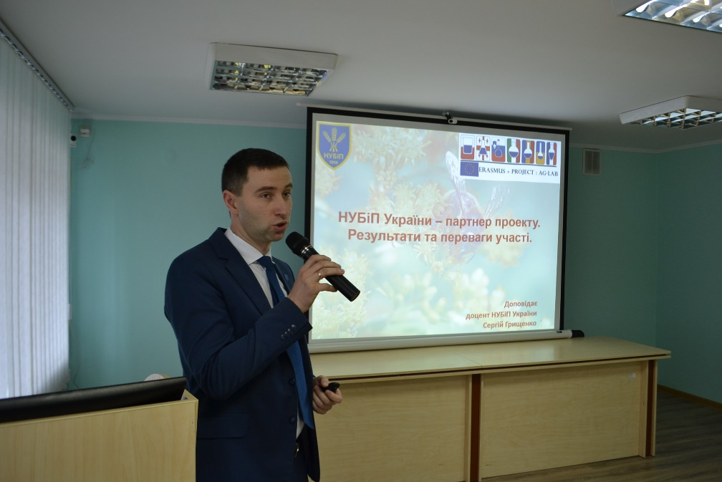
Ggalyna Ostrovska, graduator of the training programme “laboratory practice in animal husbandry” of the faculty of animal husbandry and fishery of NUBiP shared her experience in the participation in the project and her training at the University of Ljubljana. During their training at the University of Ljubljana s=the students works at the laboratory of genetic researches of the biotechnology faculty, were trained to carry out meat control at slaughter house, worked at the laboratories of the veterinary faculty and the insemination center “Preska”. The obtained experience helped her to find the work just after the gradation from the university.
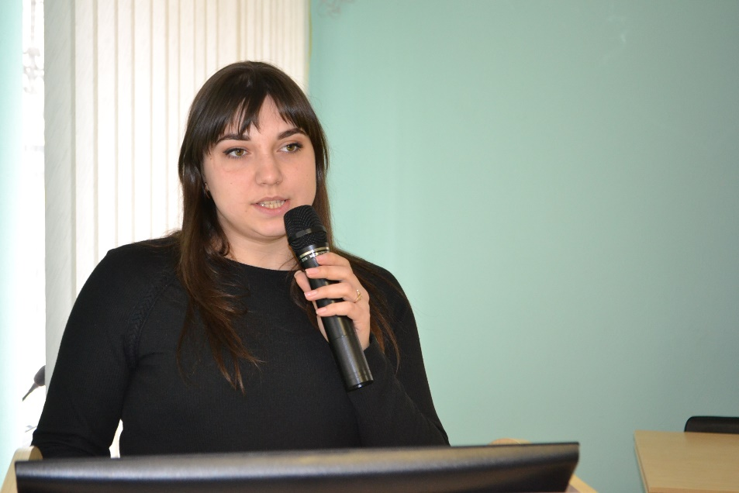
Ganna Kyivska, scientific secretary of the State research institute of laboratory diagnostic and veterinary-sanitary expertise. Ganna presented the role of the Institute in the project that is the following: development together with the universities the specialized master programmes for veterinary specialists, participation in the edition of the manual devoted to the laboratory practice, participation of the Institute specialists in the training carried out at partner-universities of EU, Ukraine, Moldova and Georgia for improving their professional level; application of the obtained knowledge and skills for the trainings organized by the Institute for other laboratories’ staff (in 2018 the Institute trained 95 specialists from other laboratories, in 2019 – 131 persons); support of the universities – project partners in the training of masters specialized on the laboratory practice by providing them the possibilities to follow the practical training at the laboratories of the Institute.
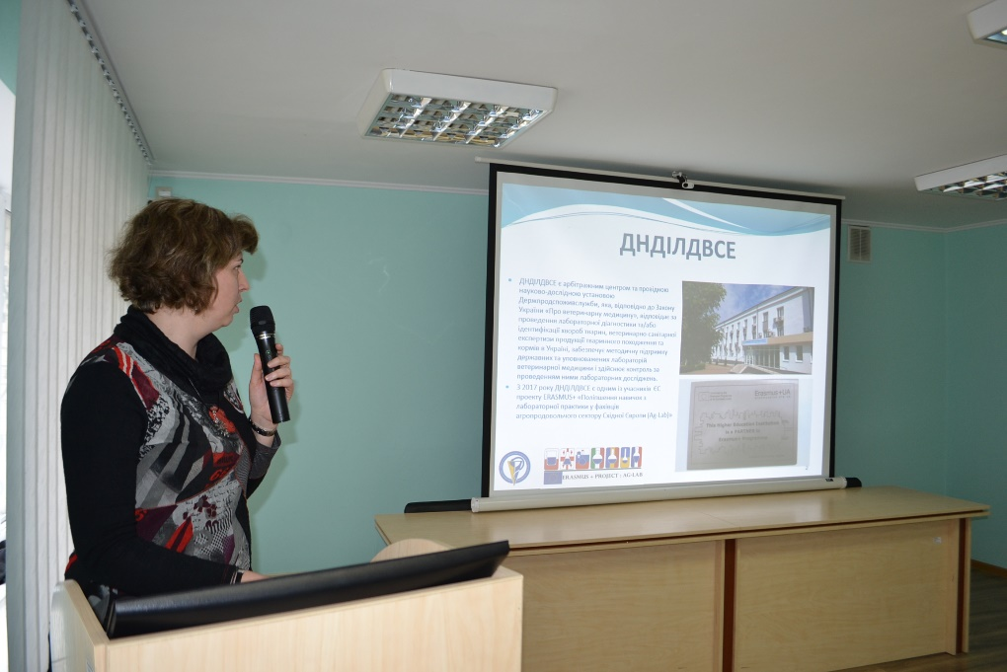
Stefanyk Vasyl, head of the department of international relations of Lviv national university of veterinary medicine and biotechnologies presented the participation of the university in the project: implementation of the educational programme "Laboratory practice" in the master course veterinary medicine, training of teachers and students at the European HEIs - project participants, organization of the steering group meeting and the training session for project participants at the university. Mr. Stefanyk emphasized the cooperation of the University with the Lviv state regional veterinary laboratory and the Institute of veterinary drugs and feed additives, which are not members of the consortium, but are actively involved in the activities organized within the project.
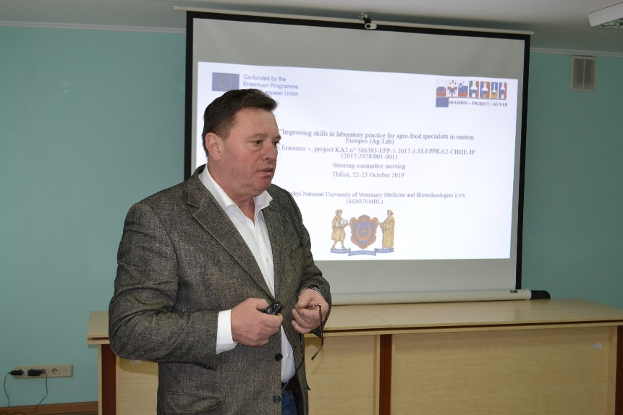

Mykhaylo Rublenko, professor at the faculty of veterinary medicine of Bila Tserkva national agrarian university analyzed the state of the pilot training of specialists in the laboratory practice, shared his views on the future prospects and risks of its development in Ukraine. He outlined the following ways for further implementation of the project results in Ukraine: optimization of the pilot course within the veterinary medicine training program with 60 credits for specialization and introduction of postgraduate internship system up to 1 year, revision of postgraduate education strategy, principles and methodology, development of pedagogical resources and improvement of the methodology of training specialists in the laboratory practice, implementation of permanent joint scientific-practical and methodological seminars of the laboratory service, university teachers and students, search for grants (joint projects for internship of teachers and students). Among the risks, he noted the following: lack of state support in the development of laboratory work and training of specialists; lack of motivational component for students to study laboratory practice and to work in the laboratory service; no clear vision of the needed number of laboratory specialists; uncertainty in the competencies required from laboratory specialists; lack of the state certification of graduators of the educational programme devoted to the laboratory practice.
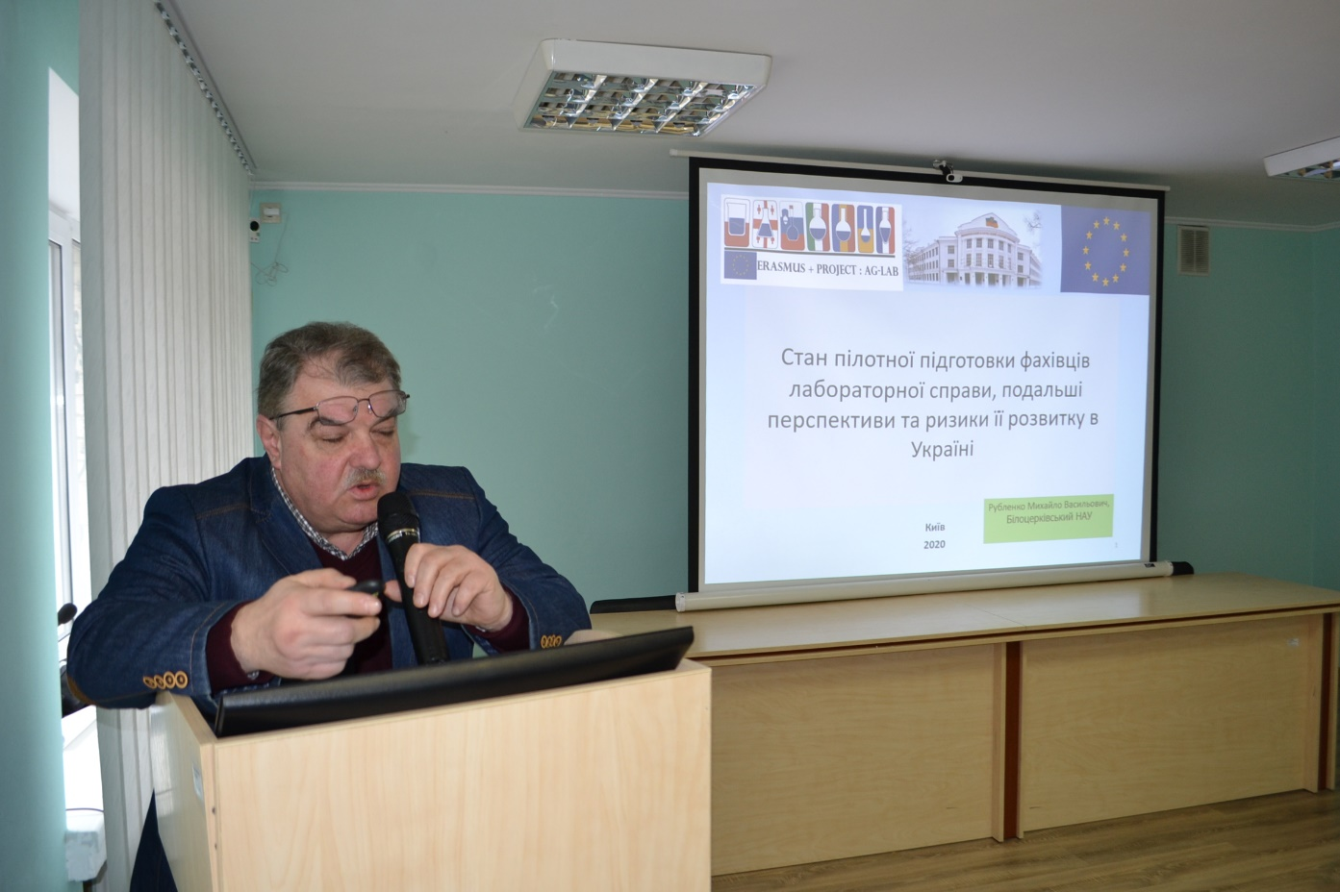

Lyubov Lytvyn and Maria Muravskaya, second year master students of the veterinary faculty of Bila Tserkva national agrarian university trained according to the educational programme “laboratory practice” shared their impressions of the internship at t Wroclaw University of Natural Sciences and several Ukrainian laboratories. They noted a big difference in the level of material base of Ukrainian and Polish laboratories and expressed their vision on ways of improving the situation: providing information on existing vacancies to universities by laboratories, increasing funding of veterinary medicine faculties by the state, optimizing the education quality, development of new projects involving other institutions, countries, and including institutions within Ukraine, optimizing the education for internationally recognized diplomas.
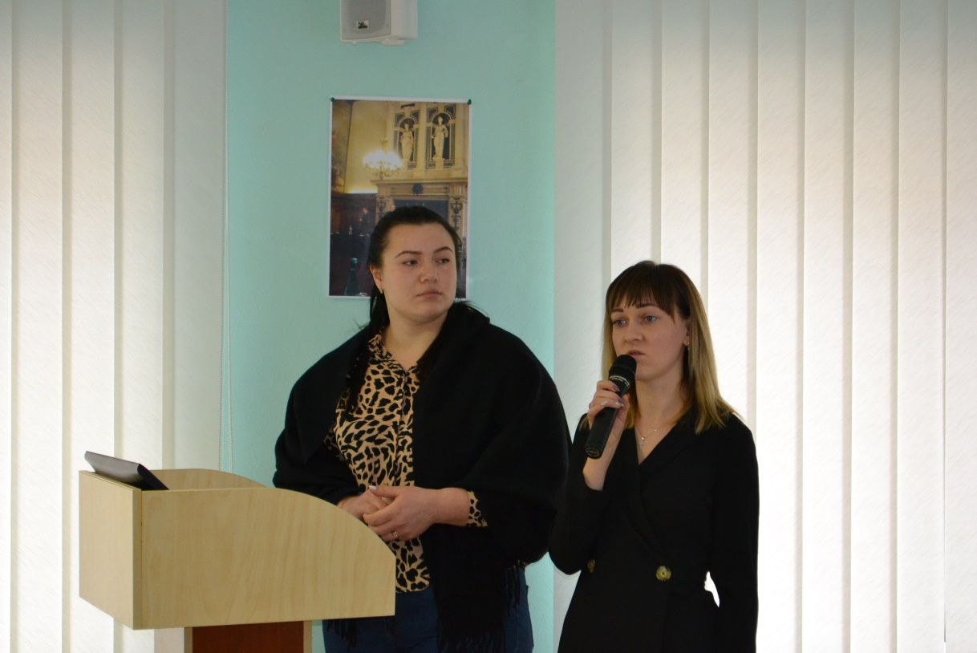
Discussion:
During the project discussion, a number of critical comments and suggestions were made for the improvement of the project and of the use its results. Thus, Ms. Jeanne Talanova noted the following:
- it is necessary to strengthen the scientific component of the project, having in the consortium research institutions, it is possible to expand cooperation through the publication of joint articles and other materials; the equipped laboratories can be used to execute commercial orders, and the gained finances can be used to fund researches carried out at the universities;
- it is important to look for ways to continue and deepen collaboration after the end of the project, for example, to prepare new academic mobility projects or projects under other programs, such as Horizon 2020 or its continuation as a new program, as spin-off is a positive indicator; to foresee the organization of joint seminars;
- Ms Talanova noted about outdated forms of both informationpresentation and assessment methods, regarding Moodle courses. It should be corrected as for the Erasmus + program it is important to introduce innovative teaching practices. Indeed, this shortcoming was acknowledged by the project participants, as during two years of the project activity, more attention was paid to content-based courses, the study of laboratory methods and standards. It was decided to devote four study trips, which remained in the third year to new teaching methods applied by European partners to this specialty;
- it is necessary to follow the national legislation, not to use the old templates, but to use the framework of qualification: knowledge, skills, communication, autonomy, responsibility;
- The strategy, methods, concept of postgraduate education should be revised as well.
The dean of the faculty of veterinary medicine of NUBiP Mykola Tsvilikhovsky and the dean of Zhytomyr agro-ecological university Anatoliy Revunets stated that the specialization "Laboratory practice" already existed at the faculties, it was canceled and then returned again. Now it is necessary to work with all the universities together so that such an educational program is firmly entrenched at faculties.

